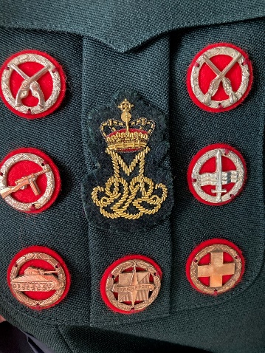
Military proficiency test: Danish combat swimmer and pistol shooting badges

Dear colleagues, dear allies.

The Reserve Forces Association of Denmark hereby invites you to join us in Copenhagen for a weekend with both a social and military aspect on 01-03 March 2024.

Our aim is to give you the possibility to earn both the Danish Armed Forces pistol shooting badge and combat swimmer badge in either bronze, silver or gold, but also to visit Amalienborg Castle to see the change of guards and spend some time at the Royal Military Academy at Frederiksberg Castle.

To earn the pistol shooting badge you’ll have to complete a series of shootings with focus on either precision, speed or both. The test is conducted with the former service pistol, Sig P210, and there will be a short weapon familiarization prior to the test. The pistol is known for its precision but can also be a bit tricky to master for the beginner. However, bronze is absolutely achievable for a shooter with some experience and our instructors will do their utmost to guide the participants. The shooting test is performed on a 25-meter range with two types of targets; a classical ring target with a 10 point center and the silhouette target.

The combat swimmer badge has a slightly misleading name since the aim of the test is to show the ability to swim and conduct life saving techniques while wearing a battle dress uniform. The participant should feel comfortable with wearing a load and rifle while performing the test in the deep end pool and basic knowledge of HLR-techniques is also mandatory in order to complete the test. Some instructions and exercises will be conducted prior to the test. Most swimmers should be able to earn the bronze badge but we would also offer you the opportunity to try the more challenging silver badge test.

In order to participate you’ll have to arrive in central Copenhagen NLT Friday 1st of March 2024 at 21.00 hrs. The event is planned to end on Sunday 3rd 2024 at 12.00 hrs. Transportation to and from Copenhagen Airport can be arranged but there are also plenty of commuter options.

Modest accommodation will be arranged at Naval Base Holmen, which is situated very centrally in Copenhagen. The shooting test is conducted nearby, as is the swimming event.

You are welcome to wear your national uniform during the planned events according to your own regulations. If you decide to do so we kindly ask you to ensure the relevant documentation (NATO travel order or
equivalent) prior to your arrival.

An updated schedule and pack list will be sent to you in advance. A fee of 1.200 DKK will be required and covers accommodation, most meals and any badges acquired.

Kind regards

Kristian Teglbjærg
Deputy Chairman, LtCol-R
HPRD | Hovedorganisationen for Personel af Reserven i Danmark
Generalstok, Kastellet 82
2100 København Ø

